

**WEB TECHNOLOGY**

**Practice exercise-2**

**NAME:KATHIRAVAN.N**

**REG.NO:19MIS0097**

**1. Html image exercises:**

**a. Display five different images. Skip two lines between each image. Each image should have a title.**

**HTML CODE:**

<html>

<head>

<title>Picture</title>

</head>

<body>

<h1><font size="5">My pic</h1>

<img src="123.jpg" width="400" height="300" vspace="50"/><br></br>

<h2><font size="5">College pic 1</h2>

<img src="IMG_20191104_154727.jpg" width="400" height="300" vspace="50"/><br></br>

<h3><font size="5">College pic 2<h3>

<img src="IMG_20191104_154728.jpg" width="400" height="300" vspace="50"/><br></br>

<h4><font size="5">College pic 3</h4>

<img src="LRM_EXPORT_207886038760318_20191123_135636940.jpeg.jpg" width="400" height="300" vspace="50"/><br></br>

<h5><font size="5">College pic 4</h5>

<img src="20191108_174731.jpg" width="400" height="300" vspace="50"/><br></br>

</body>

</html>

INPUT:

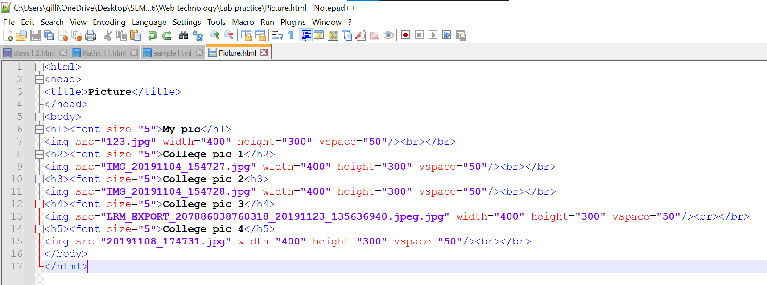

OUTPUT:

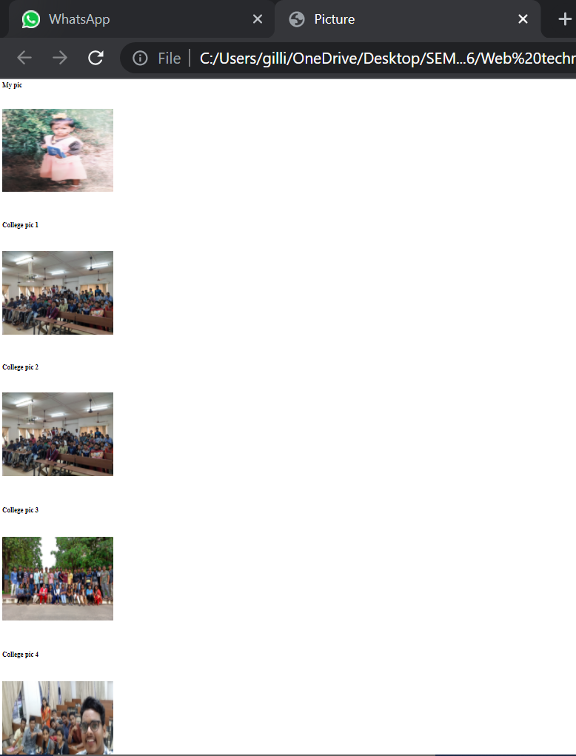

**b.Display an image that has a border of size 2, a width of 200, and a height of 200.**

**HTML CODE:**

<html>

<head>

<title>Picture</title>

</head>

<body>

<h1><font size="5">College pic 3</h1>

<img src="LRM_EXPORT_207886038760318_20191123_135636940.jpeg.jpg" width="200" height="200" border="2"/><br></br>

</body>

</html>

INPUT:

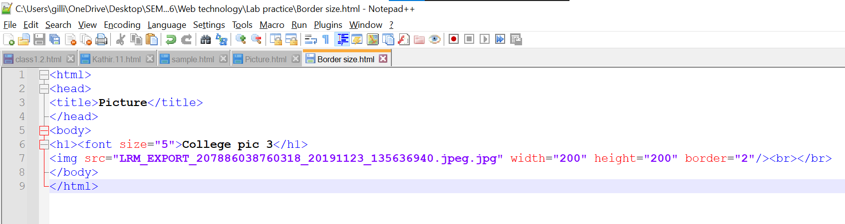

OUTPUT:

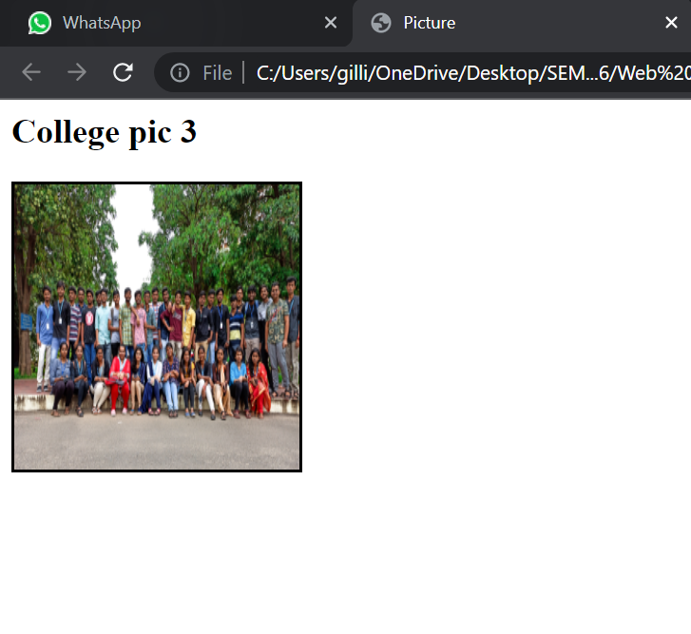

c.Display the image towards the right corner of the webpage

HTML CODE:

<html>

<head>

<title>Picture</title>

</head>

<body>

<h1><p align="right"><font size="5">College pic 3</h1></p>

<p align="right"><img src="LRM_EXPORT_207886038760318_20191123_135636940.jpeg.jpg" width="200" height="200"/></p>

</body>

</html>

**INPUT:**

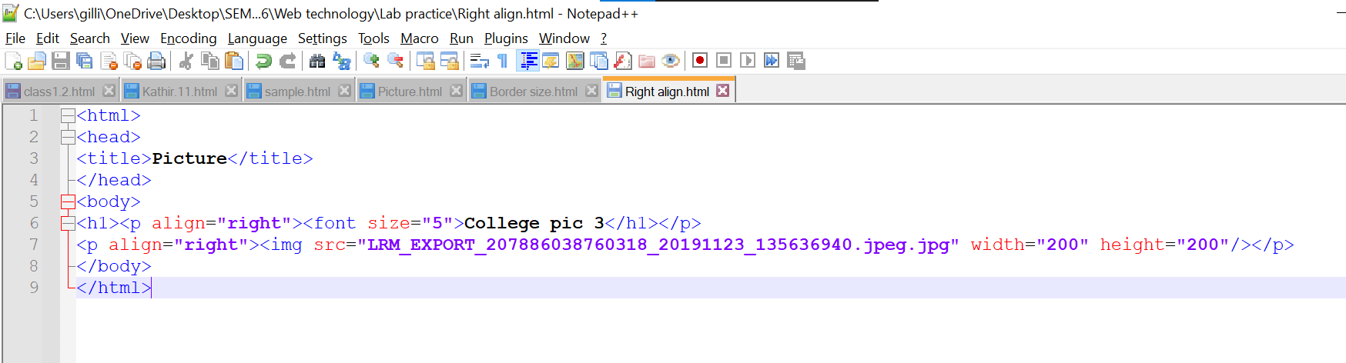

OUTPUT:

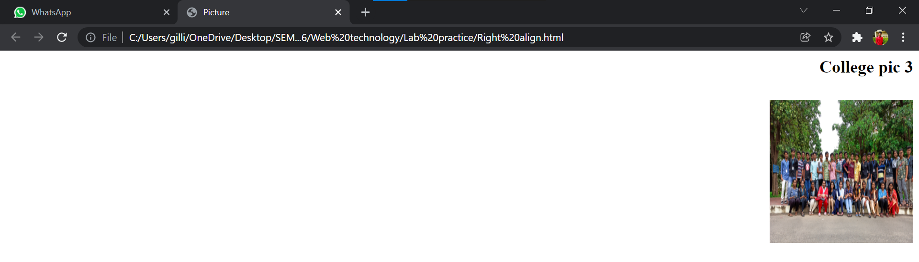

**2.HTML LIST EXERCISES:**

**a. Write the html code for the for the nested list.**

HTML CODE:

<html>

<head>

<title>Exercise 2</title>

</head>

<body>

<br>This is an unordered list</br>

<ul>

<li>List Item 1</li>

<li>List Item 2</li>

<li>List Item 3</li>

</ul>

<br>This is an ordered list</br>

<ol type="1">

<li>List Item 1</li>

<li>List Item 2</li>

<li>List Item 3</li>

</ol>

<br>This is an ordered list starting at 10 and in upper-case roman numerals</br>

<ol type="I" start="10">

<li>List Item 1</li>

<li>List Item 2</li>

<li>List Item 3</li>

</ol>

<br>This is an unordered list nested within an ordered list</br>

<ol type="1">

<li>Walk the dog</li>

<li>Wash the car</li>

<li>Get the groceries</li>

<ul type="circle">

<li>Ground beef</li>

<li>Mozzarella</li>

<li>Lasagna Noodles</li>

<li>Pasta Sauce</li>

<li>Ricotta Cheese</li>

</ul>

<li>Clean the house</li>

<li>Take out garbage</li>

</ol>

</body>

</html>

INPUT:

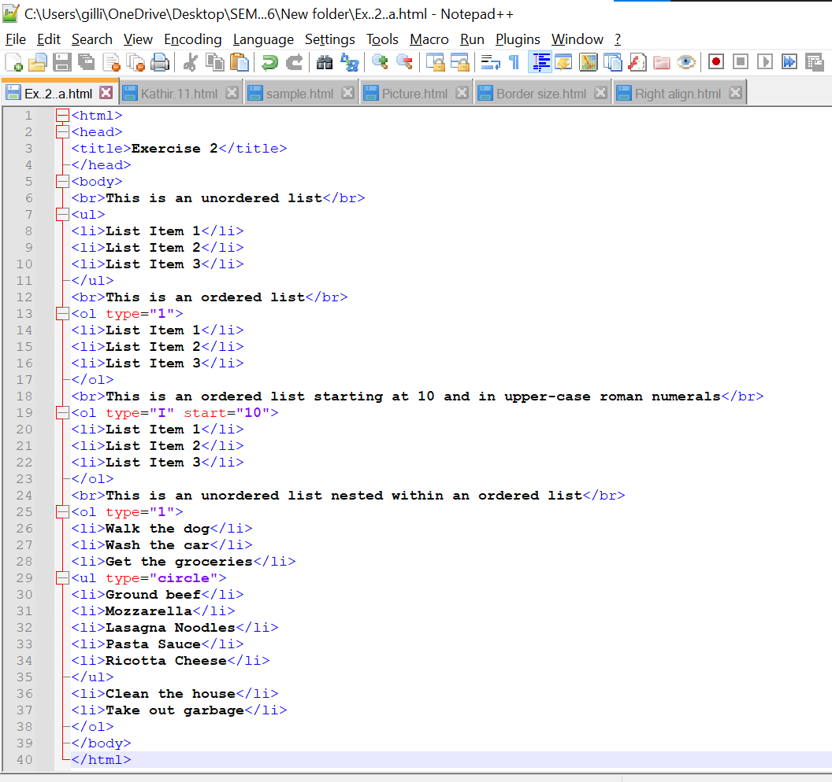

OUTPUT:

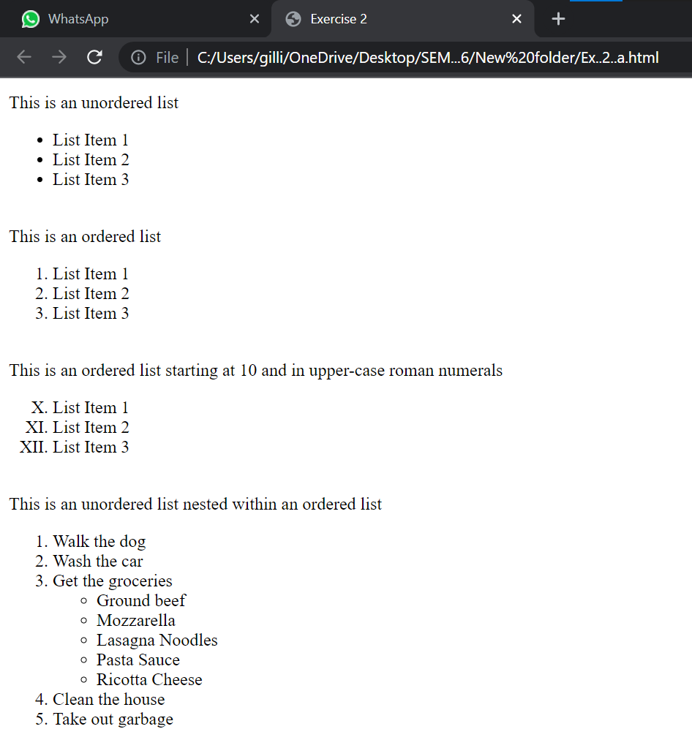

b.**Write the HTML code for the following nested ordered list and definition list.**

**HTML CODE:**

<html>

<head>

<title>Definition list</title>

</head>

<body>

<h1><font size="4"> An ordered nested list:</h1>

<ol type="1">

<li>Coffee</li>

<li>Tea</li>

<ol type="a">

<li>Black tea</li>

<li>Green tea</li>

<ol type="i">

<li>China</li>

<li>Africa</li>

</ol>

</ol>

<li>Milk</li>

</ol>

<h2><font size="4"> An ordered nested list:</h2>

<dl>

<dt>Banglore</dt>

<dd>Capital of Karnataka</dd>

<dt>Mumbai</dt>

<dd>Capital of Maharashtra</dd>

</dl>

</body>

</html>

INPUT:

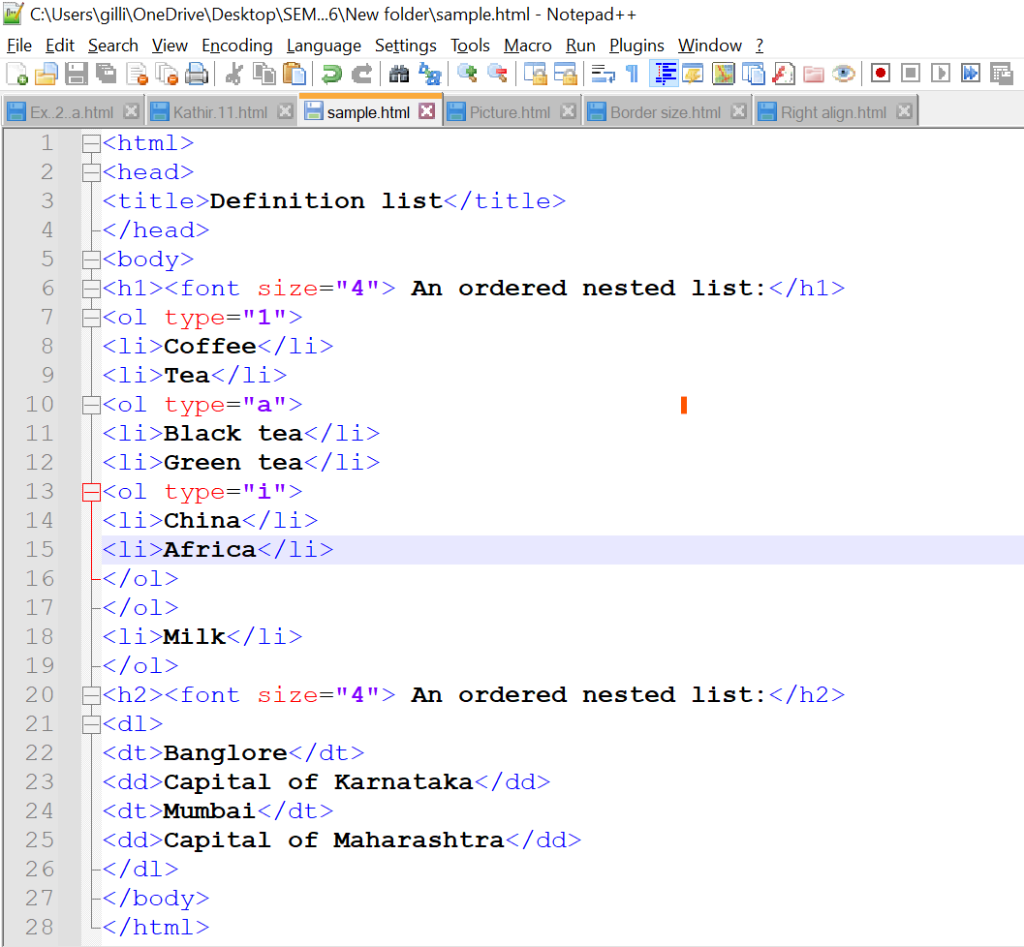

OUTPUT:

